**Employment-related US Permanent Visas, 2011-2016: Applicant Attributes**

Sanaz Jamloo, Sangeeta Nandi, and Omer Orhan (*alphabetic order, by last name*)

Fall 2018

# **Project Introduction and Motivation**

## The Department of Labor (DOL) issues permanent labor certifications that allow employers to hire foreign workers who can permanently work in the United States. These certifications are subject to certain legal and procedural conditions that protect the rights and opportunities of U.S workers. Employment-related permanent visas between 10 and 15 percent of all permanent residence visas issued annually by the US - for example, they comprised 12 percent of permanent visa certifications in 2016 (calculated from [Department of Homeland Security](https://www.dhs.gov/immigration-statistics/readingroom/LPR/request1)). However, these visas are central drivers of the American immigration story in Silicon Valley, including for the three members in the project team.

## **Research Objectives, and Approach**

The team began the project idea hoping to prove the following central hypothesis: that positive work visa outcomes are influenced by work in in-demand economic sectors and wages (where wages are a proxy variable that showcases higher education levels and skills-intensive in-demand jobs).

However, as described below, the dataset has a preponderance of categorical variables. Therefore, the ols regression exercises in the project attempt to predict relationships between wages of visa applicants with factors that may influence them, for example, economic sector, and state of work.

Give the above, the project:

1. Explores variables within the dataset
2. Performs diagnostics to identify features and outliers in the numerical wage variable
3. Conducts logit regression exercises to predict for influences on visa outcomes
4. Conducts old regressions to predict for influences on the wages of visa applicants

Also, a combination of Base R, readr, dplyr, and ggplot2 codes were used for the project.

**Data Source**

The project dataset is sourced from [Kaggle.com](https://www.kaggle.com/jboysen/us-perm-visas). Kaggle attributes the US Department of Labor as the primary data source. The large dataset is a winzip file that we downloaded and imported into R.

> us_perm_visas <- read_csv("Data Analysis - R/Project/us_perm_visas.csv")

Also: > dataset <- read.csv("c:/us_perm_visas.csv", header = TRUE, sep = ",", stringsAsFactors= FALSE)

> dataset<-us_perm_visas  
> dim(dataset)|  
[1] 374362 154

**Time frame** (unique(dataset$decision_date)**:** Variable observations range from 2011 - 2016.

**Variable Selection**

After checking for the variables using the head command (> head(dataset)), the following subset was initially chosen for further analysis

>dataset< subset(dataset,select=c("country_of_citzenship","case_status","class_of_admission","decision_date","employer_city","employer_state","wage_offer_from_9089","us_economic_sector"))

***List of Variables***

1. country_of_citizenship
2. case_received_date
3. case_status (process decision)
4. class_of_admission (prior visa)
5. decision_date
6. employer_city
7. employer_state
8. Worker_birth_country
9. Foreign_worker_education
10. Foreign_worker_info_major
11. Wage_offer_from_9089
12. Wage_offer_unit_of_pay_9089
13. us_economic_sector

The class of each of the above variables were verified as follows:

> sapply(dataset,class)

* which reconfirmed that the dataset has one date variable (decision_date), one numerical variable (wage_offer_from_9089), and the rest are all character variables

For ease of analysis, we changed column names as follows > #Changing column names

> colnames(dataset)=c("COUNTRY", "STATUS","VISA","DATE","CITY","STATE","WAGE","INDUSTRY")

We also checked for unique values in each variable, and the length of each unique variable.

For example:

>unique(dataset$VISA)

> length(unique(dataset$VISA))

[1] 57 ….

The above exercise illustrated that there were 57 types of visa applications that could lead to permanent residence in the US. These include H2-B and TPS visa types that are not heard of as often as, for example, the H1-B and H-4.

In general, this exercise of investigating the observations within each column allowed us to spot anomalies in variable definitions. For example:

> length(unique(dataset$STATE))

[1] 113

* But, 113 states is an impossible result considering the US has 50 States. Looking through the unique variable names, we found that states are represented in the dataset in two ways: as their full forms (e.g. California) and as their acronyms (e.g. CA). Also, the data includes US territories like Marshall Islands.

Similarly, exploring the wage variable, i.e. the singular numerical variable in the dataset, showed anomalies that lead to more detailed diagnostic exercises about it. These are reported below.

**The wage variable: a deep diagnostic dive**

We unsuspectingly (or rather, naively) began the analysis with the assumption that the wage variable referred to yearly wages only. Checking for summary statistics showed a wide (and unreal) range between the minimum and maximum values of the wage variable.

> summary(wage)

Min. 1st Qu. Median Mean 3rd Qu. Max. NA's

1 68557 90750 91224 114296 11175840 224718

The presence of outlying ranges was further confirmed by plotting (and boxplotting) the wage variable. More than the boxplot, a simple scatter plot demonstrated the anomalies in the distribution of the wage variable more dramatically (> plot(wage))

**Figure: Scatterplot of wage variable (before removing NAs)The** 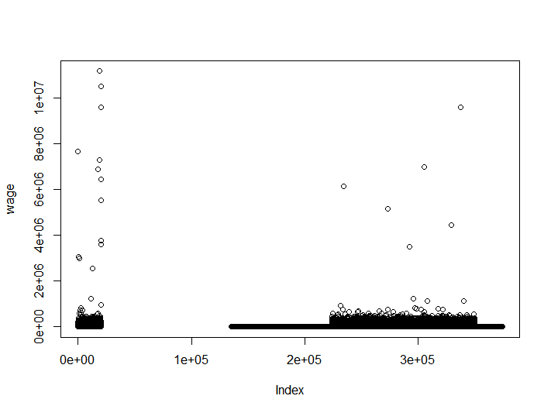

The above prompted another look at the raw data, where we found that wages were represented in atleast 11 different units. Therefore, the subset under consideration was expanded to include the variable "wage_offer_unit_of_pay_9089", which, we found comprised 11 unique units, including “NA”, “yr”, and “Year”

> unique(dataset$wage_offer_unit_of_pay_9089)

[1] "yr" "hr" "mth" "wk" "bi" NA "Year" "Hour" "Week" "Month" "Bi-Weekly"

> length(unique(dataset$wage_offer_unit_of_pay_9089))

[1] 11

Given an anticipated logit regression exercise, described below, the following were undertaken:

* The wage variable was extracted for only those observations that referred to “Year” or “yr” as the unit of pay
* NAs for the wage variable were removed as part of of subset that includes additional variables to be utilized in the logit regressions

> wage_yr<-subset(dataset,wage_offer_unit_of_pay_9089=="yr" | wage_offer_unit_of_pay_9089=="Year", select=c("wage_offer_from_9089","us_economic_sector", "wage_offer_unit_of_pay_9089", "case_status","decision_date"))

> dim(wage_yr)

[1] 250324 5

> wage_final<-wage_yr[complete.cases(wage_yr),] #removing NA

> wage_final<-logit > dim(logit) [1] 19106 5

> 250324 -19106 #loss of observations are a result of retaining only complete cases

[1] 231218 #Implies the loss of 95% of the original number of observations in the dataset

However, after the above exercise, the wage plot smoothened out significantly

> plot(wage_final$wage_offer_from_9089) #as simplified to logit$WAGE in subsequent codes

**Figure: Scatterplot of wage variable (after removing NAs)**

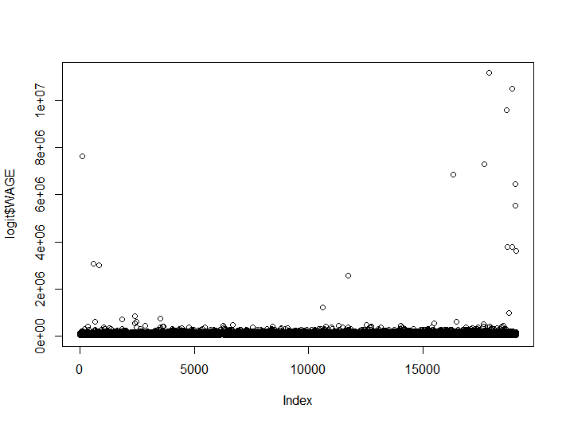

The above smoothening of the wage plot shows up in the summary statistics also (see Min. and Max.):

> summary(wage_final$wage_offer_from_9089)

Min. 1st Qu. Median Mean 3rd Qu. Max.

15142 68458 85176 95109 105934 11175840

Finally, **checking for outliers in the wage variable**:

> summary(wage_final$wage_offer_from_9089)

Min. 1st Qu. Median Mean 3rd Qu. Max.

15142 68458 85176 95109 105934 11175840

> y<-IQR(wage_final$wage_offer_from_9089)

> ylow<-68458-1.5*y

> ylow #lower determinant of outliers (values lower than this are outliers)

[1] 12244.38

> yup<-105934+1.5*y

> yup #upper determinant of outliers (values higher than this are outliers)  
[1] 162147.6

#Finding number of outliers

> outliers<-wage_final[wage_final$wage_offer_from_9089 >162147.6 , ]

> dim(outliers)

[1] 940 5

> low_outliers<-wage_final[wage_final$wage_offer_from_9089<12244.38 , ]

> dim(low_outliers)

[1] 0 5

Omitting wage outliers implies the loss of an additional 940 observations from an already diminished dataset (i.e. 19106-940 observations). This extremely diminished dataset perhaps contributes to its becoming ‘statistically insignificant’ as a predictor of visa outcomes in the logit regressions below.

**Predicting for visa outcomes through logit regressions: an attempt**

To set up the ground to (attempt to) predict for visa outcomes, we had to first convert the visa decision observations to a binary variable, where “Certified” = 1, all else =0)

> unique(logit$STATUS) #Four possible visa outcomes

[1] "Certified" "Denied" "Certified-Expired" "Withdrawn"

#Converting the status variable to binary

> logit$STATUS[logit$STATUS == "Certified"] <- 1

> logit$STATUS[logit$STATUS == "Denied"] <- 0

> logit$STATUS[logit$STATUS == "Certified-Expired"] <- 0

> logit$STATUS[logit$STATUS=="Withdrawn"]<-0

> unique(logit$STATUS) #unique results of variable conversion

[1] "1" "0"

> class(logit$STATUS) # checking for the class of the converted status variable

[1] "character"

#Converting the class of the status variable from character to numeric to enable logit regressions

> lookup <- c("0" = 0, "1" = 1)

> head(logit$STATUS)

Having converted the dependent (visa status variable) to a binary, we needed to ensure that the variable was a numeric to be successfully run logit (a form of generalized least squares) regressions. For these equations, the following data subset was chosen:

> wage_yr<-subset(dataset,wage_offer_unit_of_pay_9089=="yr" | wage_offer_unit_of_pay_9089=="Year", select=c("wage_offer_from_9089","us_economic_sector", "wage_offer_unit_of_pay_9089", "case_status","decision_date","country_of_citzenship"))

> dim(wage_yr)

[1] 250324 6

> wage_final<-wage_yr[complete.cases(wage_yr),]

> wage_final<-logit

> dim(wage_final)

[1] 19106 5

> logit<-wage_yr[complete.cases(wage_yr),]

> dim(logit)

[1] 19104 6

#Changing column names to simplify model codes

> colnames(logit)<-c("WAGE","INDUSTRY","UNIT OF PAY","STATUS","YEAR","COUNTRY")

We ran several logit models, unfortunately with statistically insignificant results. The table below describes three of these models and their key results, to help explain the exercises.

**Table: Logit Model specifications and overview of regression results**

|  |  |
| --- | --- |
| **Model specification (select)** | **>summary(mylogit): regression overviews** |
| > mylogit <- glm(STATUS ~ WAGE+INDUSTRY+COUNTRY, data = logit, family = "binomial") (Wage, Industry, Country) | 6 INDUSTRY coefficients significant per p values, model residuals indicate poor fit |
| > mylogit_wage <- glm(STATUS ~ WAGE, data = logit, family = "binomial") (WAGE) | Only the intercept is significant (perhaps we will get different results by grouping the variables by country or economic sector – to be done) |
| > mylogit_industry <- glm(STATUS ~ INDUSTRY, data = logit, family = "binomial") (Industry) | Intercept + 8 industry coefficients (i.e., Agribusiness, Construction, IT, Hospitality, Other Economic Sectors, Educational services, homeland security, Transportation) are significant. **AIC score** comparisons indicate that this model specification marginally the best among all of those that were attempted |

***For illustrative purposes, the summary results of the third model above are as follows:***

> summary(mylogit_industry)

Call: glm(formula = STATUS ~ INDUSTRY, family = "binomial", data = logit)

**Deviance Residuals:**

Min 1Q Median 3Q Max

-1.4857 -1.2394 0.9609 1.0413 1.6651

Null deviance: 26013 on 19103 degrees of freedom

Residual deviance: 25824 on 19087 degrees of freedom

**AIC: 25858;** Number of Fisher Scoring iterations: 4

The high values of the null deviance and the residual deviance indicate that these logit models were poorly specified, which is why we did not attempt to fit them into training data. Going forward, the same exercises may be attempted with the following changes, perhaps with better results: impute variable for missing wage variables so as not to diminish the dataset so significantly; and, run the logit regressions with a larger set of independent variables.

**Exploring Dataset Variables Individually**

Variable relationships wages, year, state, sector through visualization

The relation between Case Status and Number of the Cases

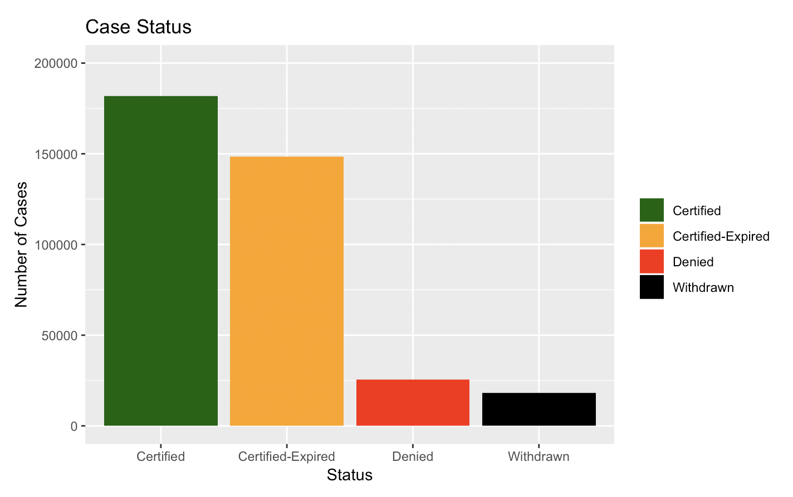

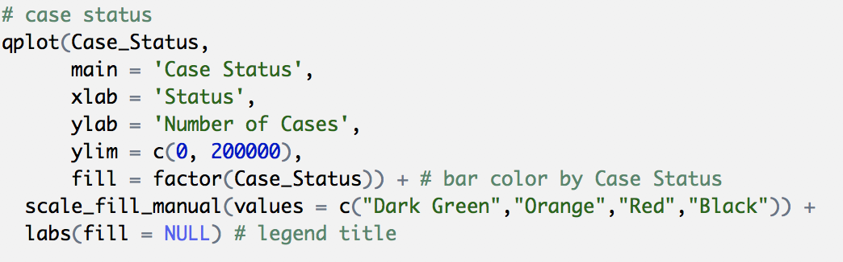

This graph shows top 10 employers by state

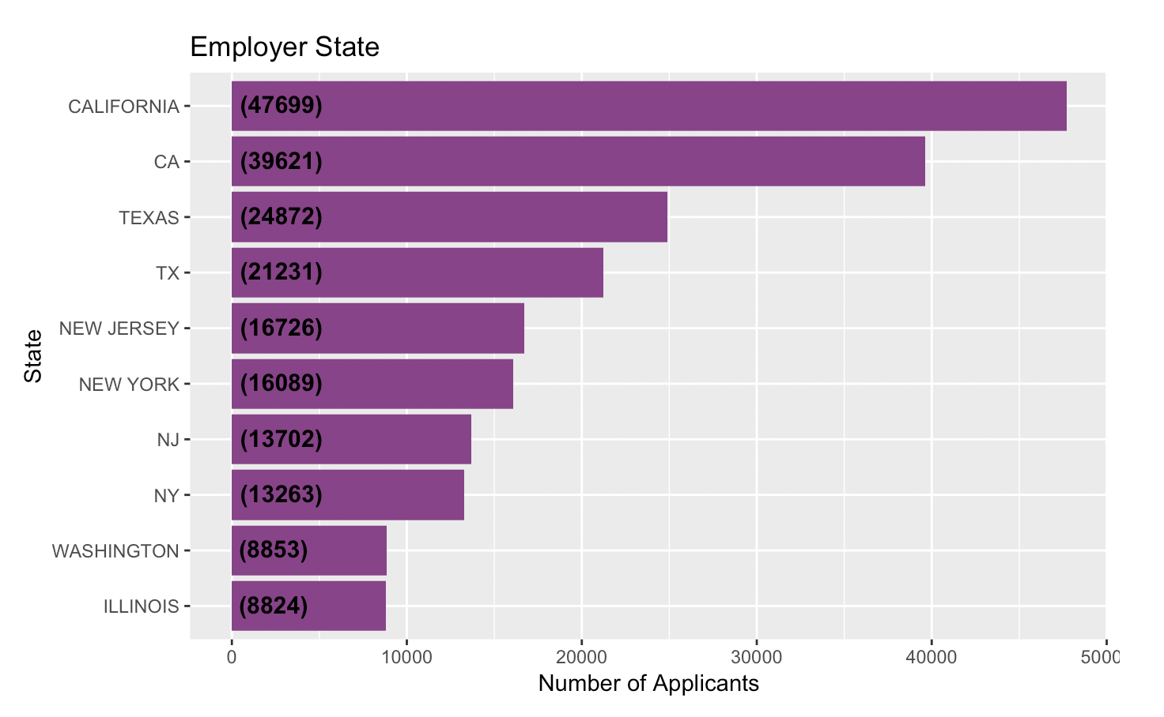

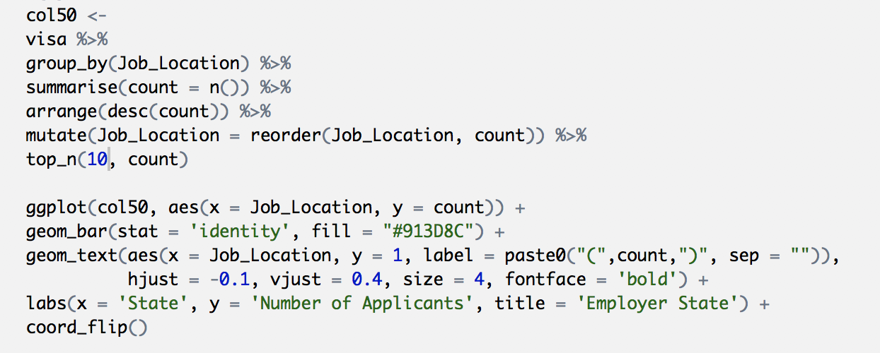

Top 20 visa types that are processed to permanent worker status

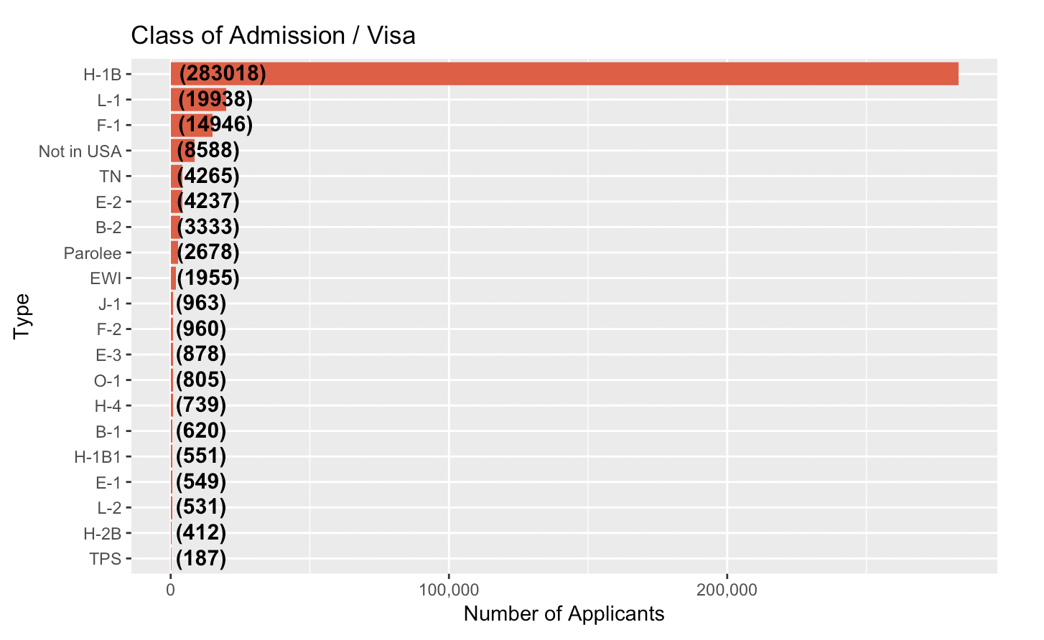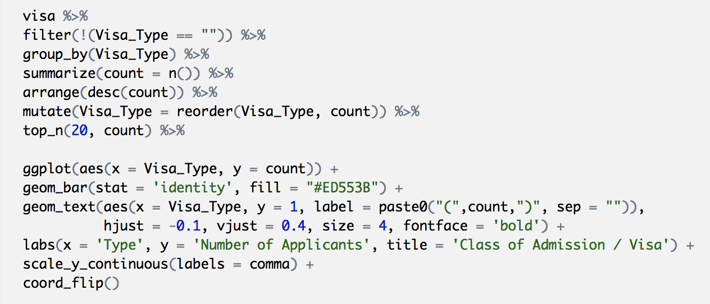

Top 20 countries for permanent worker visa applications

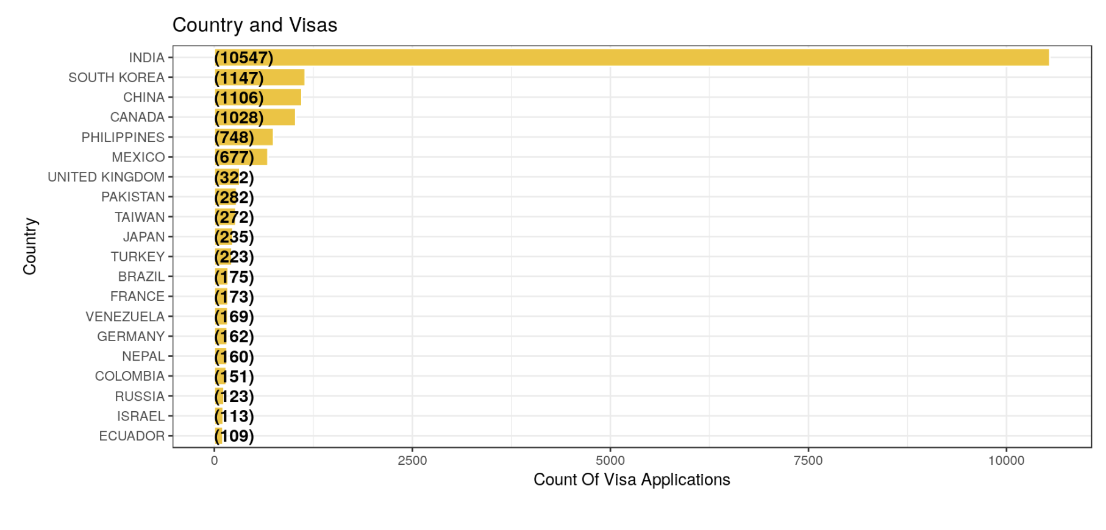

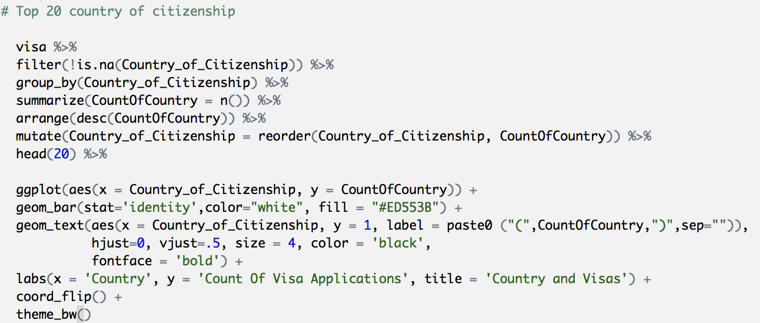

Top 20 Countries from which permanent work visas are Certified

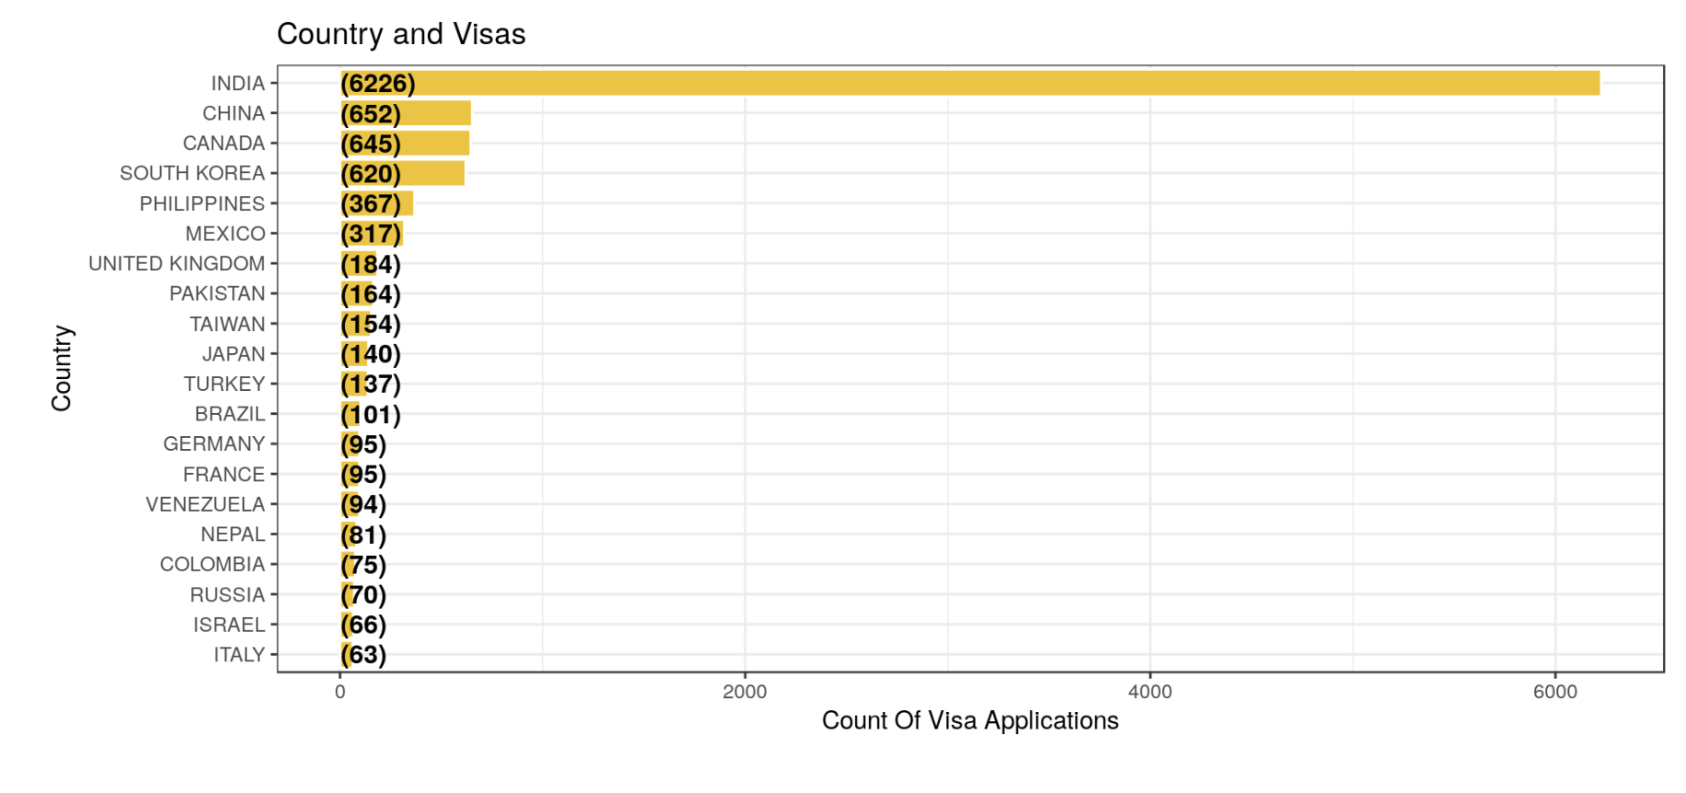

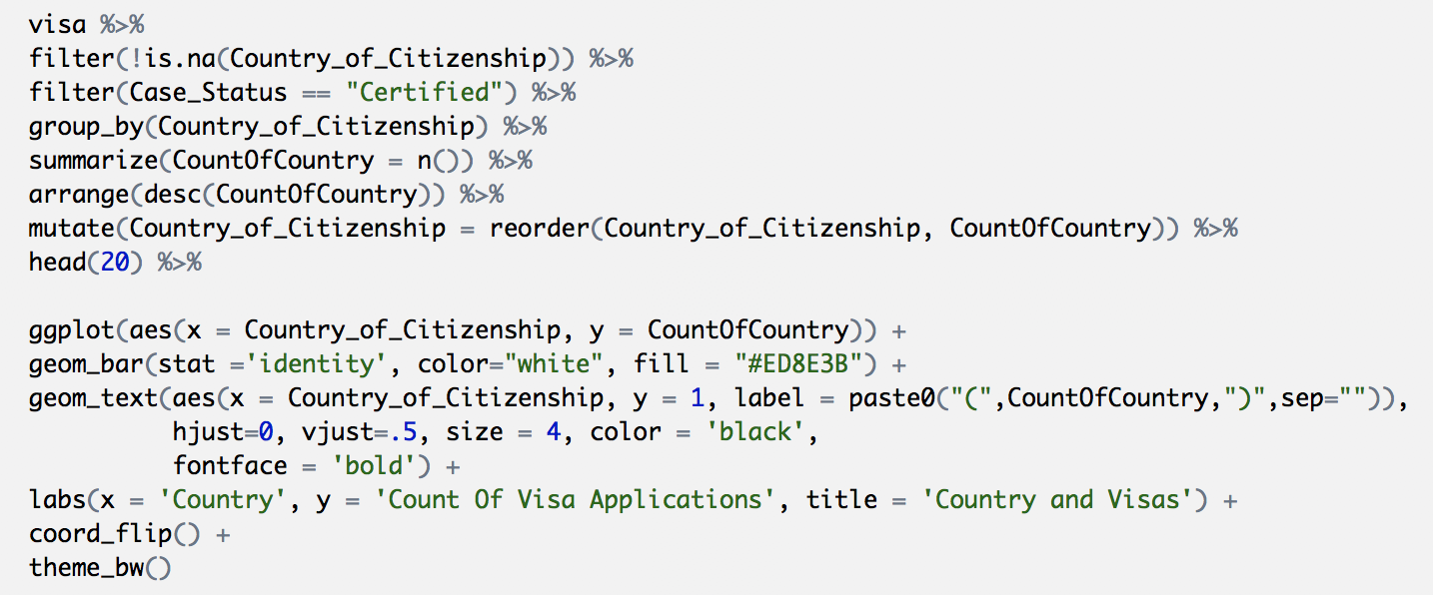

Top 20 employers of permanent worker visa applicants

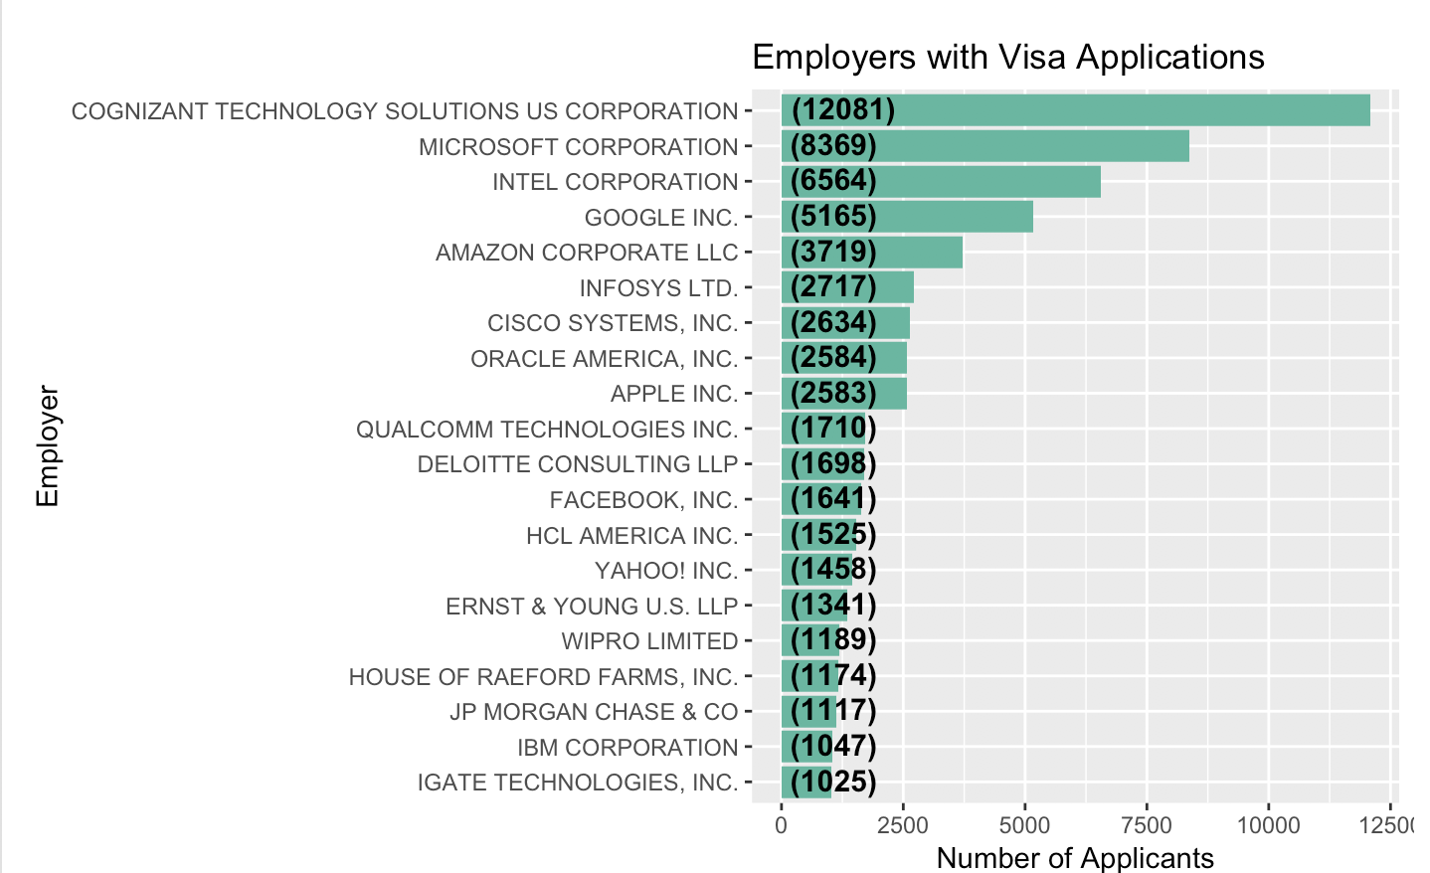

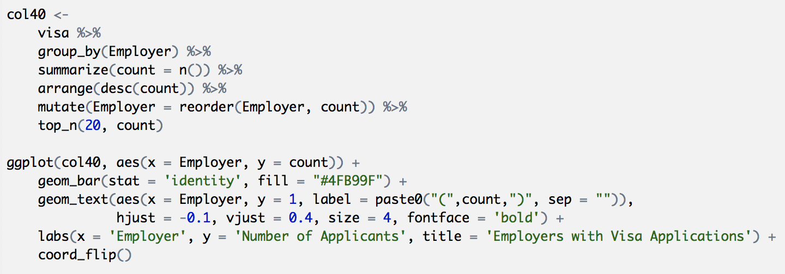

Education level of permanent visa applicants

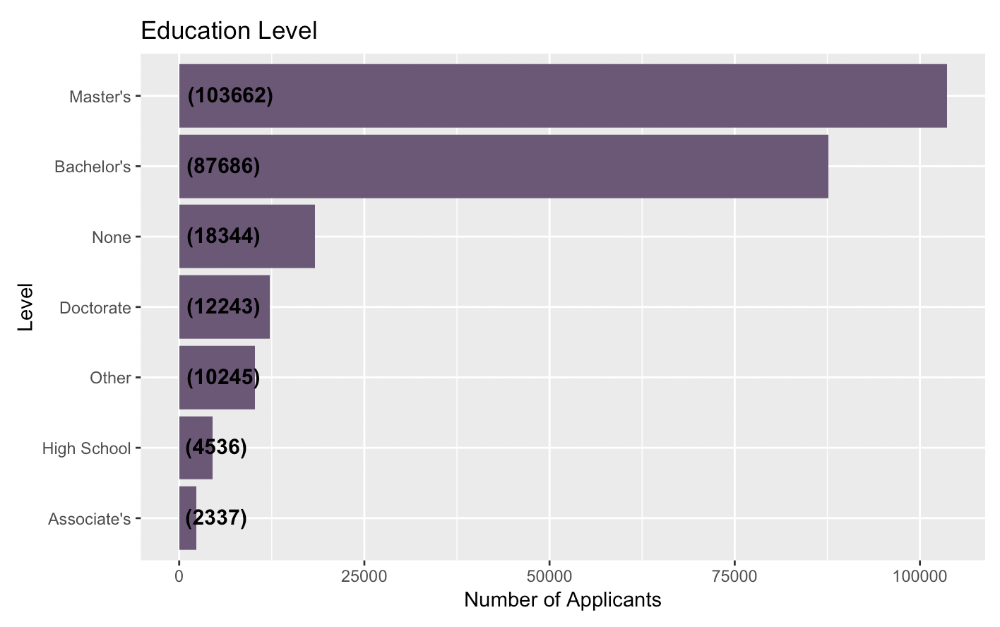

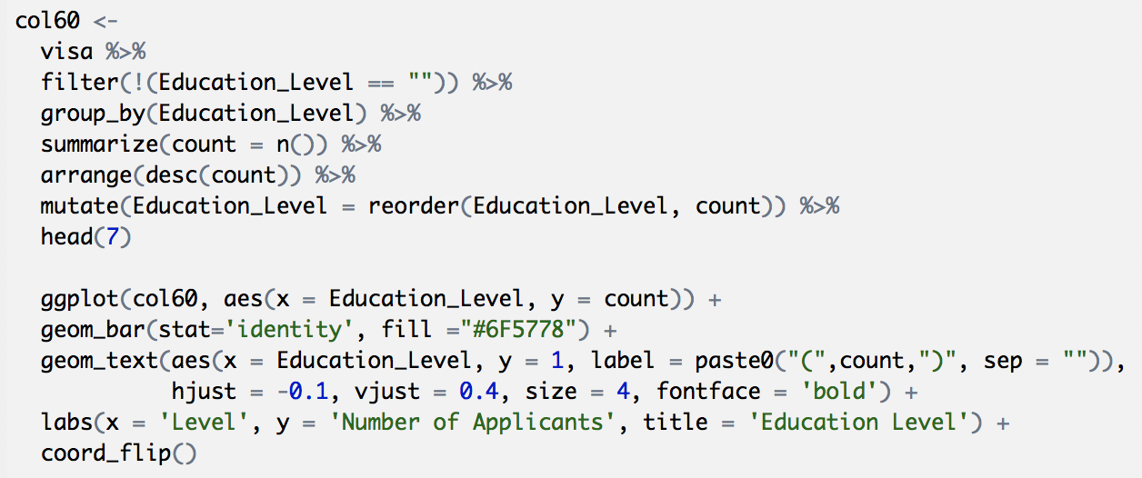

The major/field of study of visa applicants

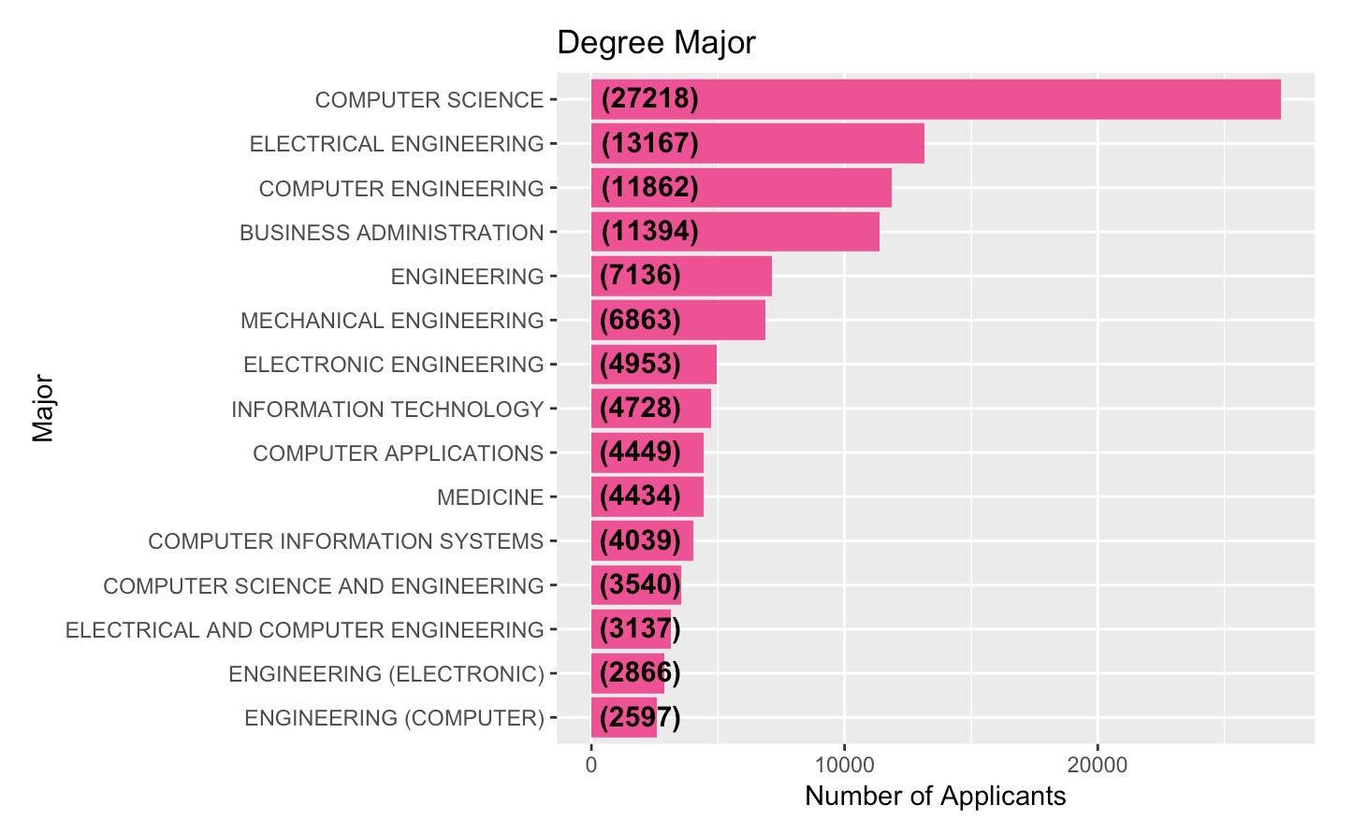

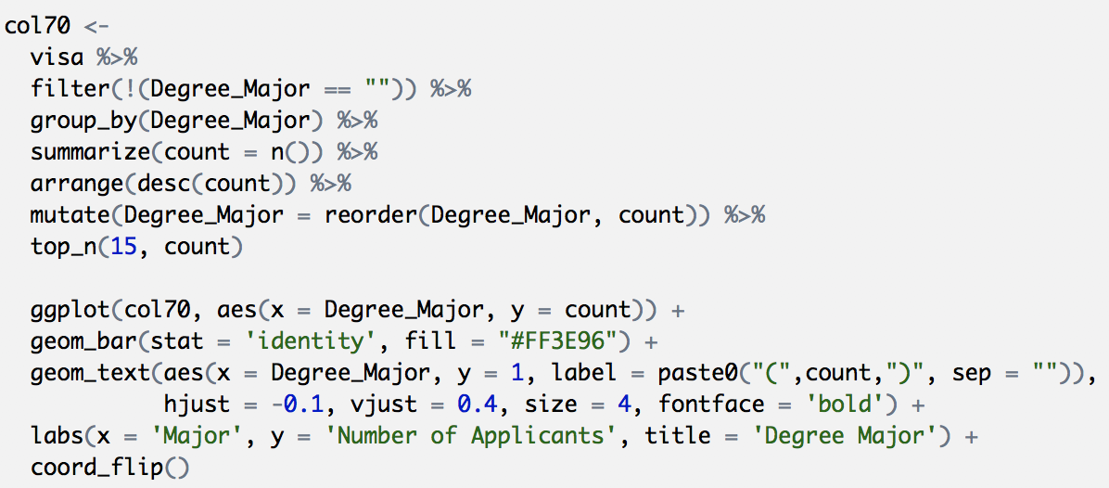

Visa applications by class of admission: top 20 countries with applicants

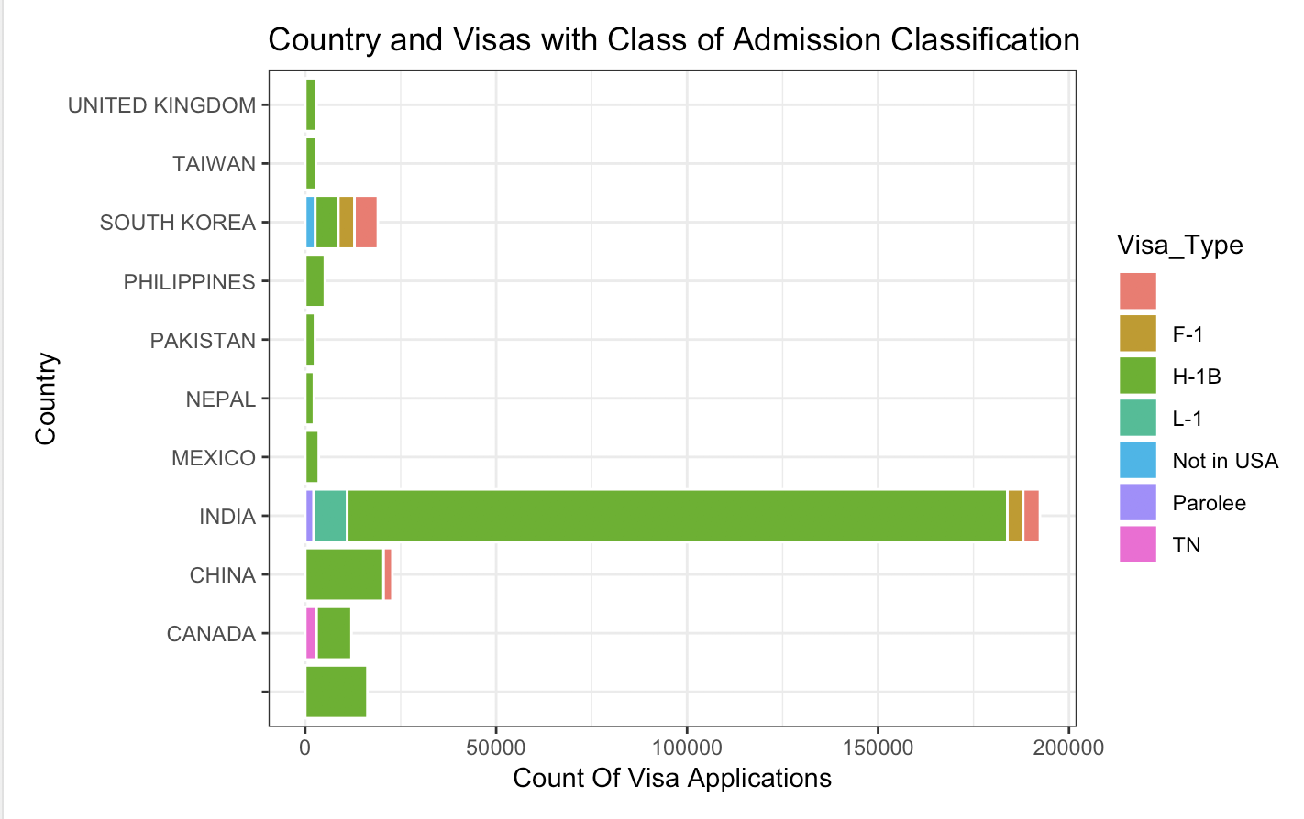

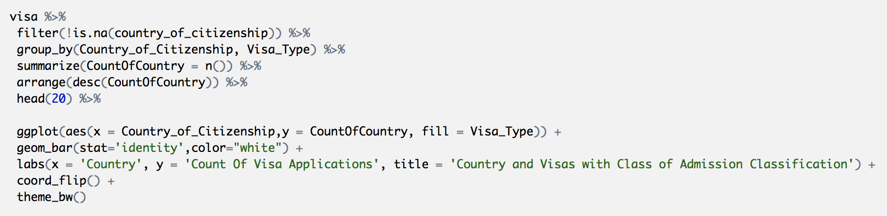

Certified visa applications by class of admission: top 20 countries

Case Status- Certified

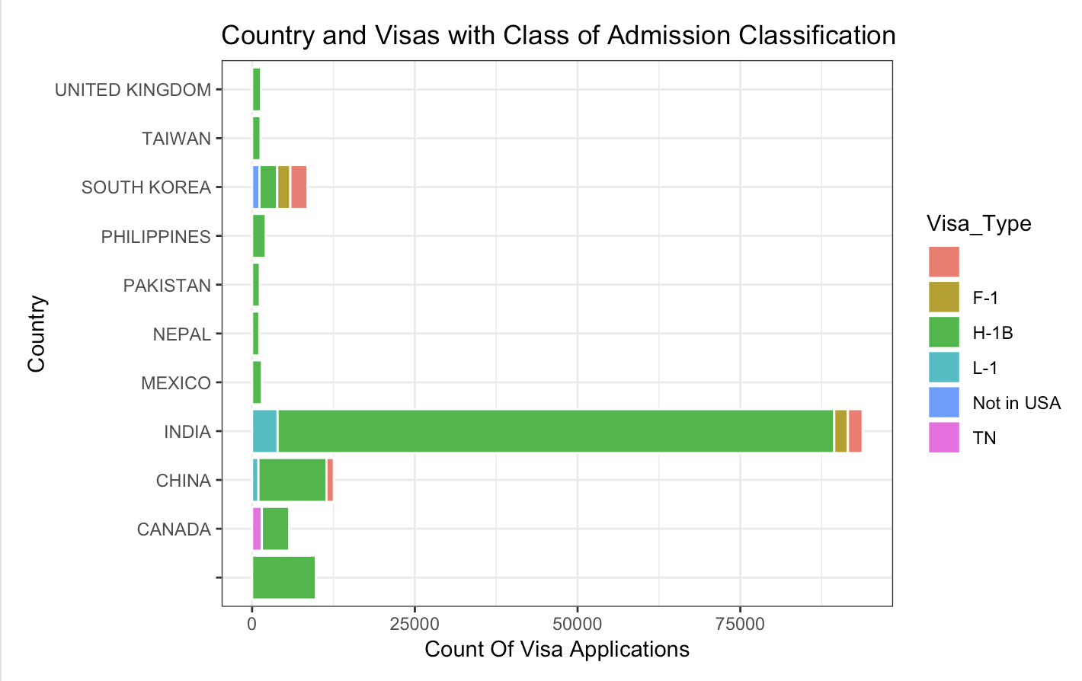



Top 20 cities that permanent worker applicants work in.

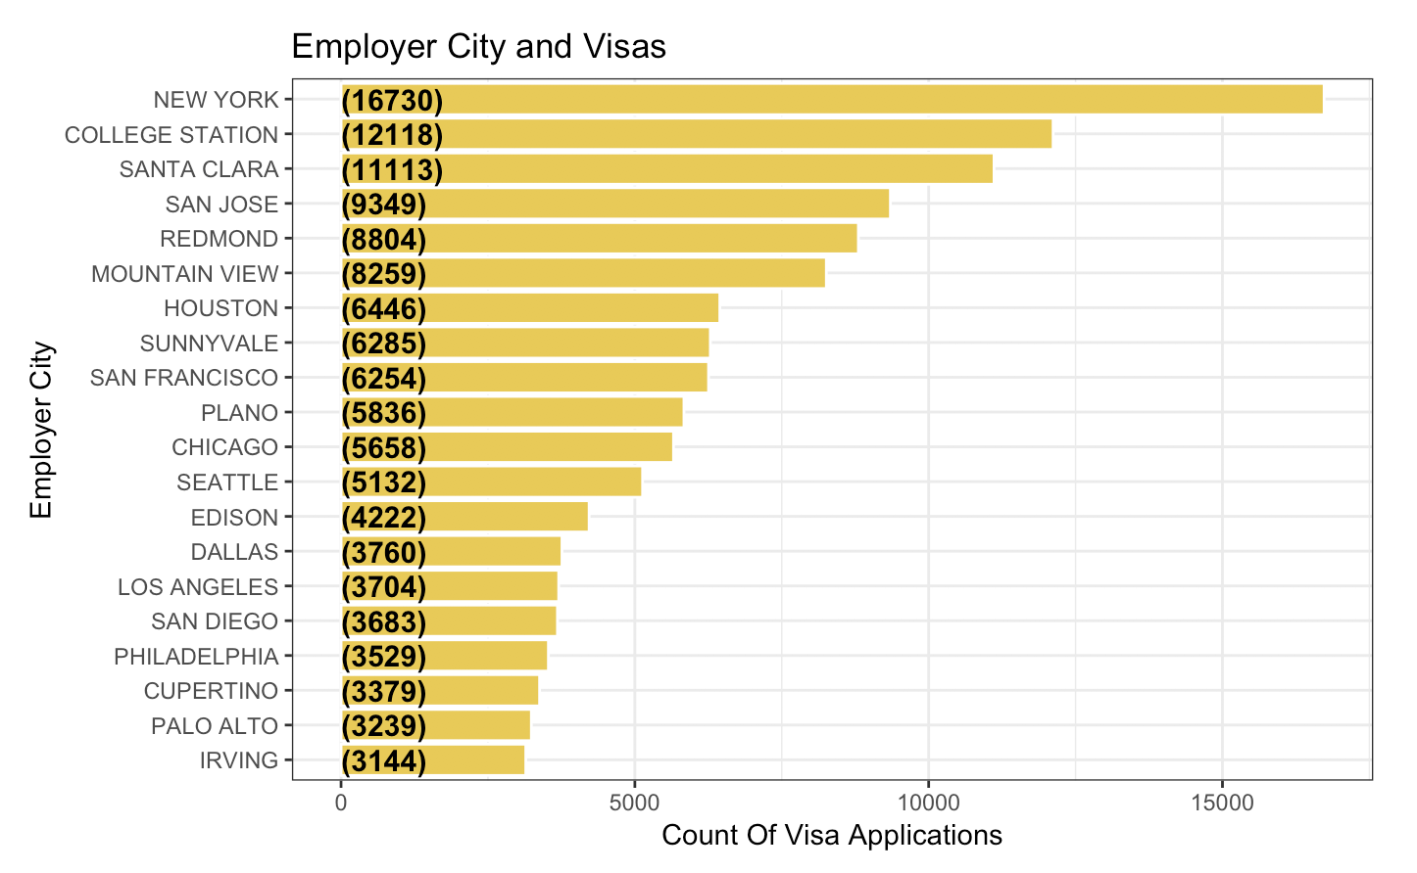

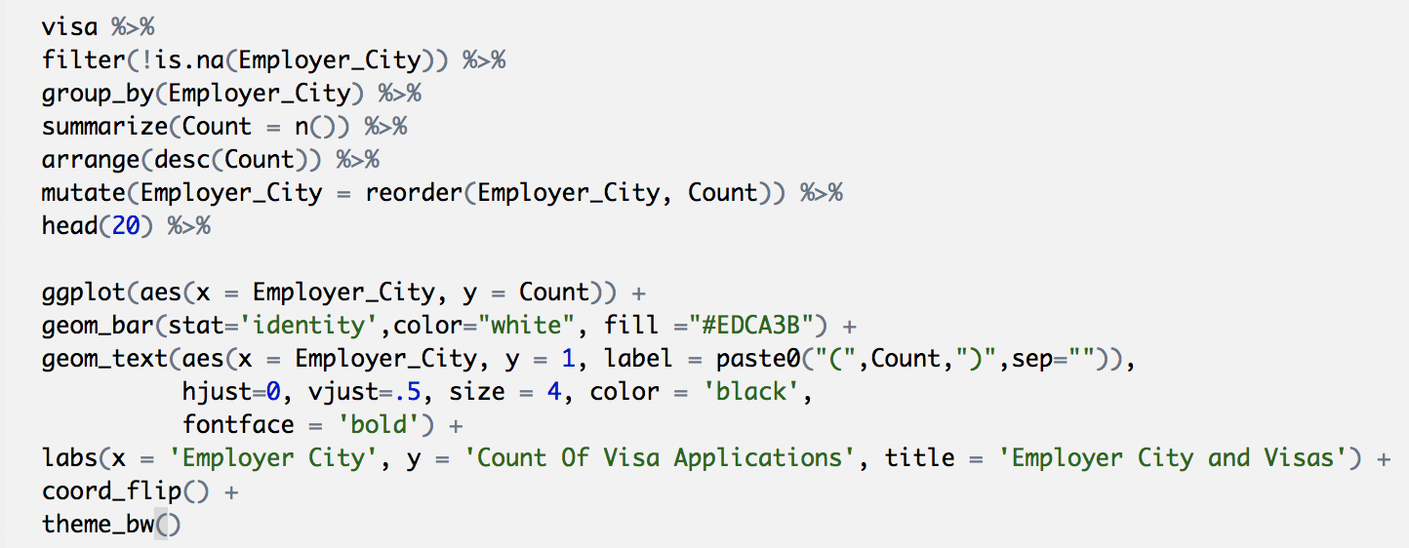

Top 20 cities that certified permanent worker applicants work in

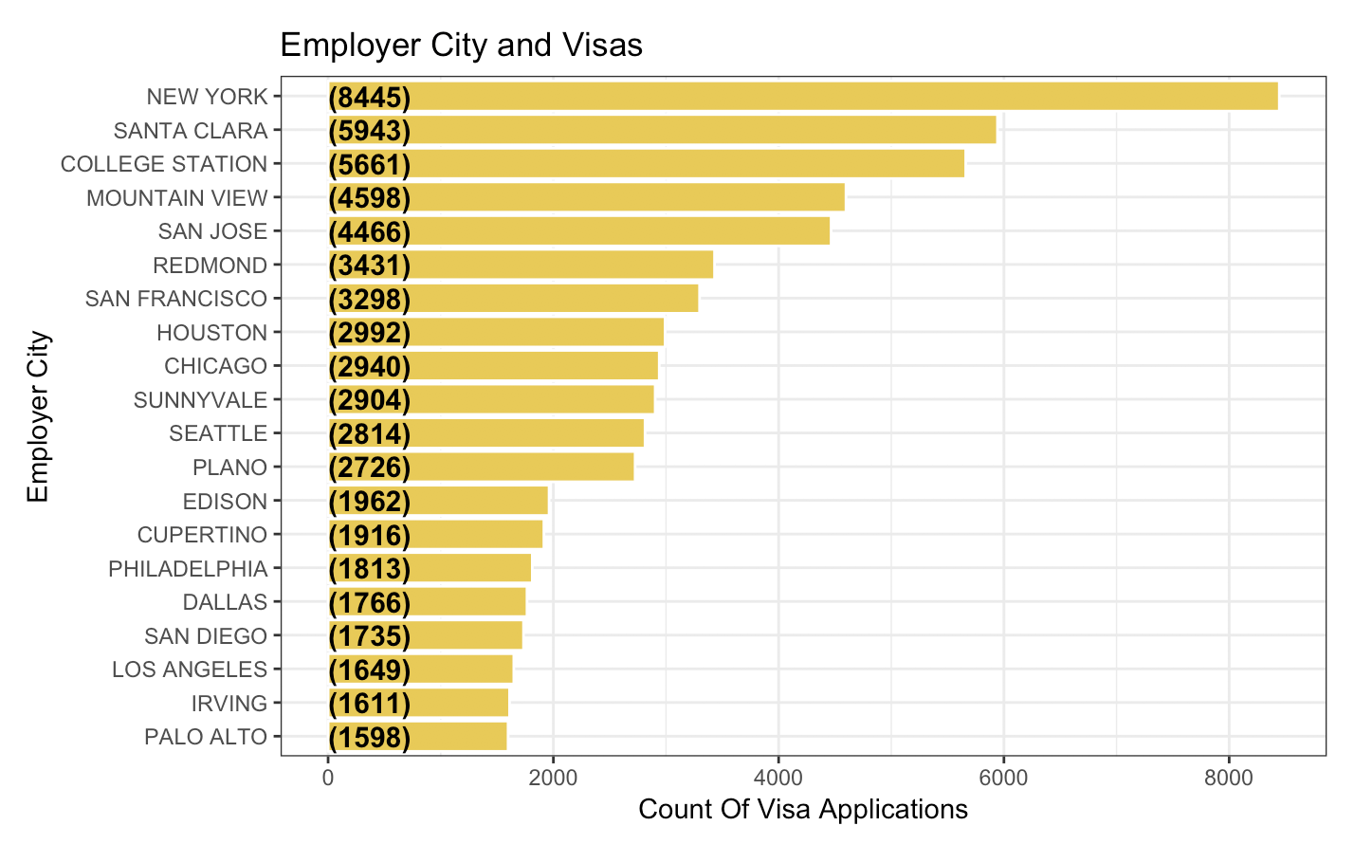

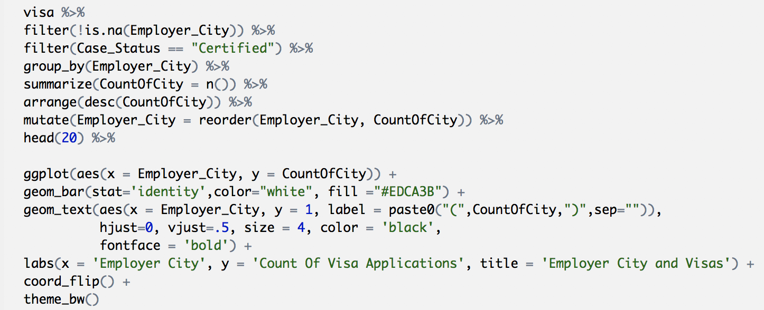

Top 20 employers in New York City

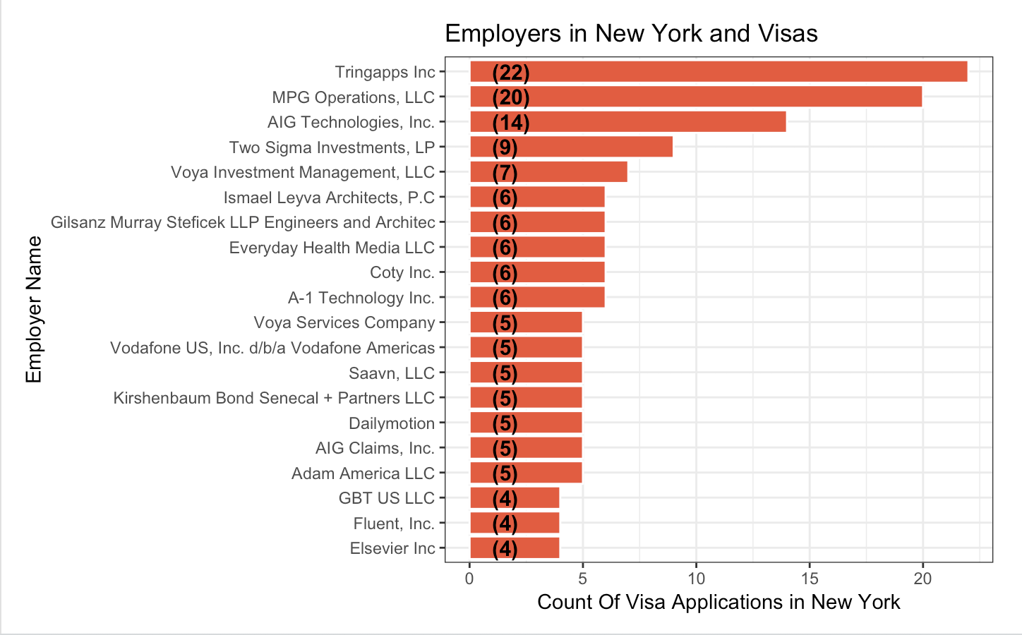

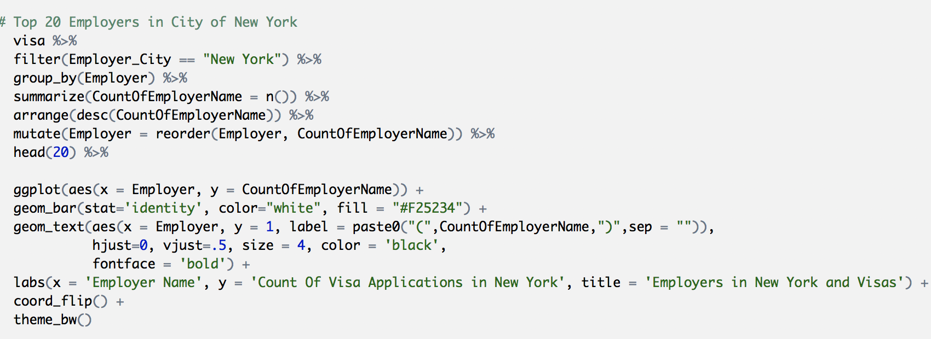

Top 20 employers in city of Santa Clara City,CA

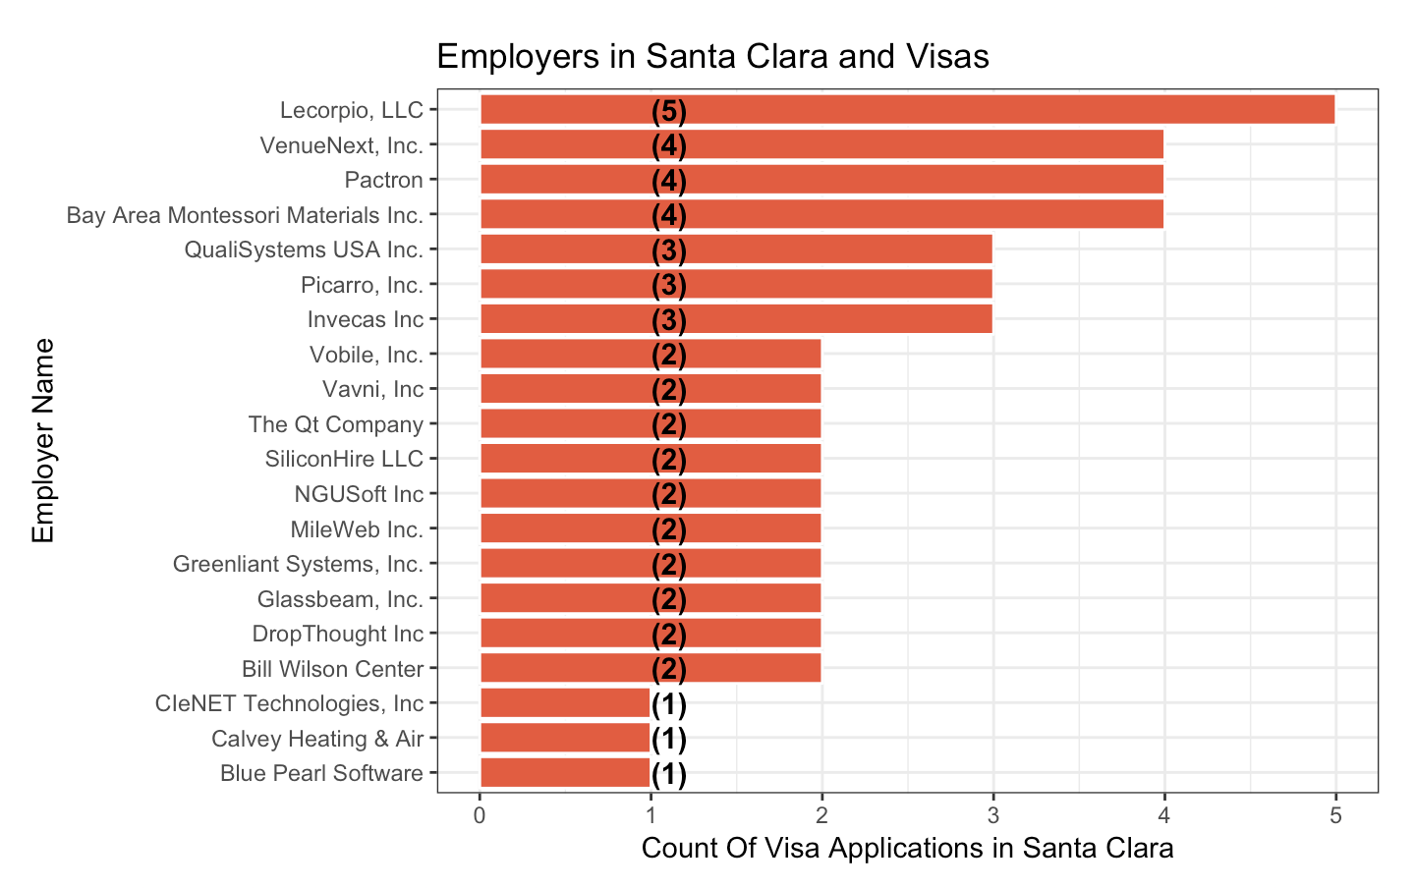

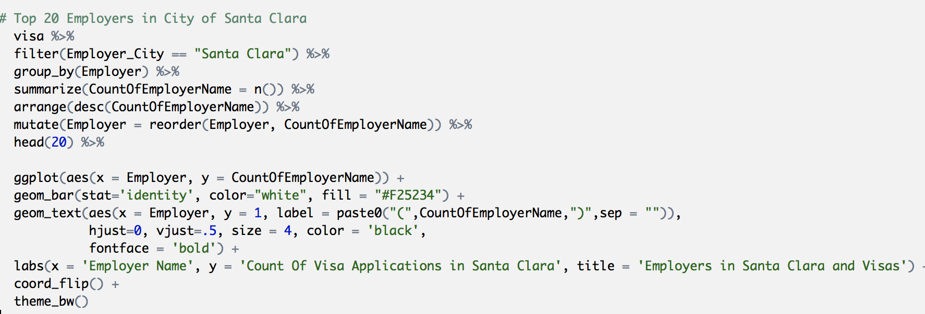

Preparing dataset for correlation matrix and subsequent modelling for data preparation, such as Case status, Wage, Wage unit, Economic sector, Application type and Class of admission have been considered. The employer name had too many levels,therefore, could not be considered. The variables shortlist was based on the type and class of the attribute. Those not considered had too many levels, or were repetitions, or simply empty lists.



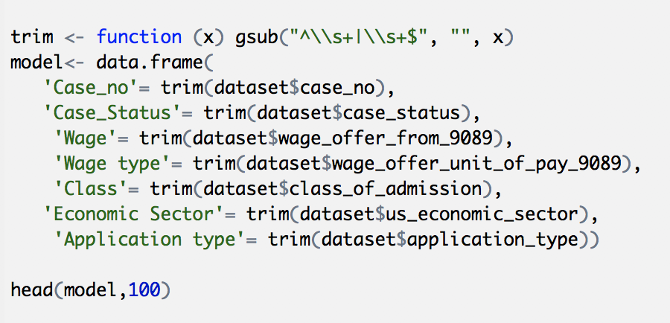

**Predictive Analysis: OLS regressions with wages as the dependent variable**

In this section, we present results ols regressions that attempt to predict wage outcomes of permanent visa seekers by industry and state. We continue to use the same dataset from [Kaggle.com](https://www.kaggle.com/jboysen/us-perm-visas). Apart from Base R, we also use dplyr and ggplot2 for these exercises.

>dataset <- read.csv("c:/us_perm_visas.csv", header = TRUE, sep = ",",

stringsAsFactors= FALSE)

**1. California & Texas wages plot**

* #Lets see sample data for the dataset by running below command which selects every 5th row starting from 1st row.
* wages <- subset(dataset, wage_offered_unit_of_pay_9089=="Year" & (job_info_work_state =="CALIFORNIA" | job_info_work_state =="TEXAS")& ( us_economic_sector=="IT" | us_economic_sector=="Finance"), select=c(wage_offered_from_9089,job_info_work_state,us_economic_sector))
* wages[wages==""] <- NA
* wages <- na.omit(wages)
* wages$wage_offered_from_9089 <- as.numeric(gsub(",", "", wages$wage_offered_from_9089))
* wages[, 'job_info_work_state'] <- as.factor(wages[, 'job_info_work_state'])
* par(mfrow=c(1,2))
* plot(wages$wage_offered_from_9089 ~ wages$job_info_work_state,xlab="State",ylab="Wage", title="State&Wage")
* wages <- wages[-which(wages$wage_offered_from_9089 %in% boxplot.stats(wages$wage_offered_from_9089)$out), ]
* plot(wages$wage_offered_from_9089 ~ wages$job_info_work_state,xlab="State",ylab="Wage", title="Boxpot - State&Wage")
* 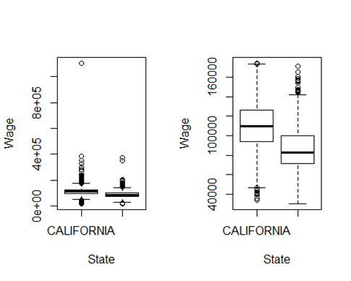

The graph shows that California wages are higher than in Texas. These graphs remove outlier’s importance since the second graph indicates clear information.

**Fınance & IT Plot**

wages[, 'us_economic_sector'] <- as.factor(wages[, 'us_economic_sector'])

par(mfrow=c(1,2))

plot(wages$wage_offered_from_9089 ~ wages$us_economic_sector,xlab="Sectors",ylab="Years", title="Years&Sector")

wages <- wages[-which(wages$wage_offered_from_9089 %in% boxplot.stats(wages$wage_offered_from_9089)$out), ]

plot(wages$wage_offered_from_9089 ~ wages$us_economic_sector,xlab="Sectors",ylab="Years", title="Years&Sector-Boxplot")

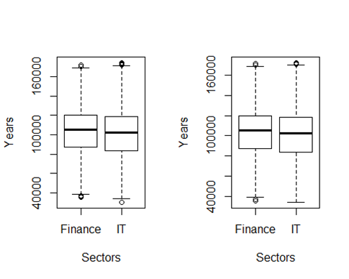

The above result surprises us because finance wages are slightly higher than IT wages.

**Salary & experience prediction**

wageYrs <- dataset[,c("job_info_alt_cmb_ed_oth_yrs","wage_offer_to_9089")]  
wageYrs[wageYrs==""] <- NA  
wageYrs <- na.omit(wageYrs)  
wageYrs$wage_offer_to_9089 <- as.numeric(gsub(",", "", wageYrs$wage_offer_to_9089))  
#plot(wageYrs$wage_offer_to_9089 ~ wageYrs$job_info_alt_cmb_ed_oth_yrs,xlab="Experience Years",ylab="Wages" )  
wageYrs <- wageYrs[-which(wageYrs$wage_offer_to_9089 %in% boxplot.stats(wageYrs$wage_offer_to_9089)$out), ]  
wageYrs.model <- lm(wage_offer_to_9089 ~ job_info_alt_cmb_ed_oth_yrs, data=wageYrs)  
#abline(wageYrs.model)  
summary(wageYrs.model)  
## Call:  
## lm(formula = wage_offer_to_9089 ~ job_info_alt_cmb_ed_oth_yrs,   
## data = wageYrs)  
## Residuals:  
## Min 1Q Median 3Q Max   
## -95280 -22130 -2830 24734 95020   
## Coefficients:  
## Estimate Std. Error t value Pr(>|t|)   
## (Intercept) 130379.55 536.87 242.851 <2e-16 ***  
## job_info_alt_cmb_ed_oth_yrs -49.94 82.26 -0.607 0.544   
## Signif. codes: 0 '***' 0.001 '**' 0.01 '*' 0.05 '.' 0.1 ' ' 1  
## Residual standard error: 30320 on 6546 degrees of freedom  
## Multiple R-squared: 5.63e-05, Adjusted R-squared: -9.645e-05   
## F-statistic: 0.3686 on 1 and 6546 DF, p-value: 0.5438  
new.data <- data.frame(job_info_alt_cmb_ed_oth_yrs=c(10,15) )  
predict(wageYrs.model, new.data, interval="confidence")  
## fit lwr upr  
## 1 129880.1 128749.9 131010.3  
## 2 129630.4 127810.3 131450.5  
par(mfrow=c(2,2))  
plot(wageYrs.model)  
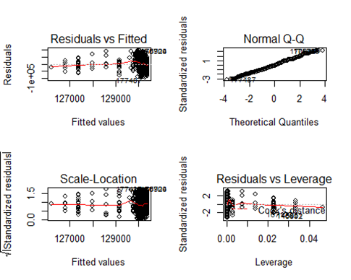

Since Pr(>|t|) is equal 0.554, the regression is insignificant. Normal Q-Q graph indicates dimensional line so it is successful. Residuals vs Fitted graph’s line is not flat, so that shows insignificant importance.

**Conclusion: Research Relevance, and Future Work**

## With immigration-related questions featuring prominently in policy priorities of successive federal administrations, this project apparently offered an opportunity to explore and better understand, at a high level, permanent worker-based settlements in the U.S. For example: Who are these workers and their employers? Where do they come from? What are their average wage levels? Most importantly, what are the factors that favorably influence permanent work-visa outcomes for applicants.

Given our results above, the above questions remain inconclusive and a work in progress. Apart from acknowledged data challenges (specifically, a preponderance of categorical variables as also missing data – including entirely empty columns), we also recognize the need to be include more variables in predictive exercises. For the latter, we would need to explore ways to impute missing variables in to analysis subset, for example through their mean/median values.

However, we’re pleased that exploring individual variables during the analysis attested to the largeness of American diversity and opportunity: permanent worker applicants during 2011-2016 originated 159 countries. Further, they lived and worked across the length and breadth of the country, and across economic sectors.